**CI CD EXPERIMENT – 8**

**(BY: AMAN TYAGI)**

**AIM:** Implementing Slave/Master Architecture in Jenkins

1. Start your Jenkins
2. Go to Manage Jenkins >> Manage nodes and cloud and select new node

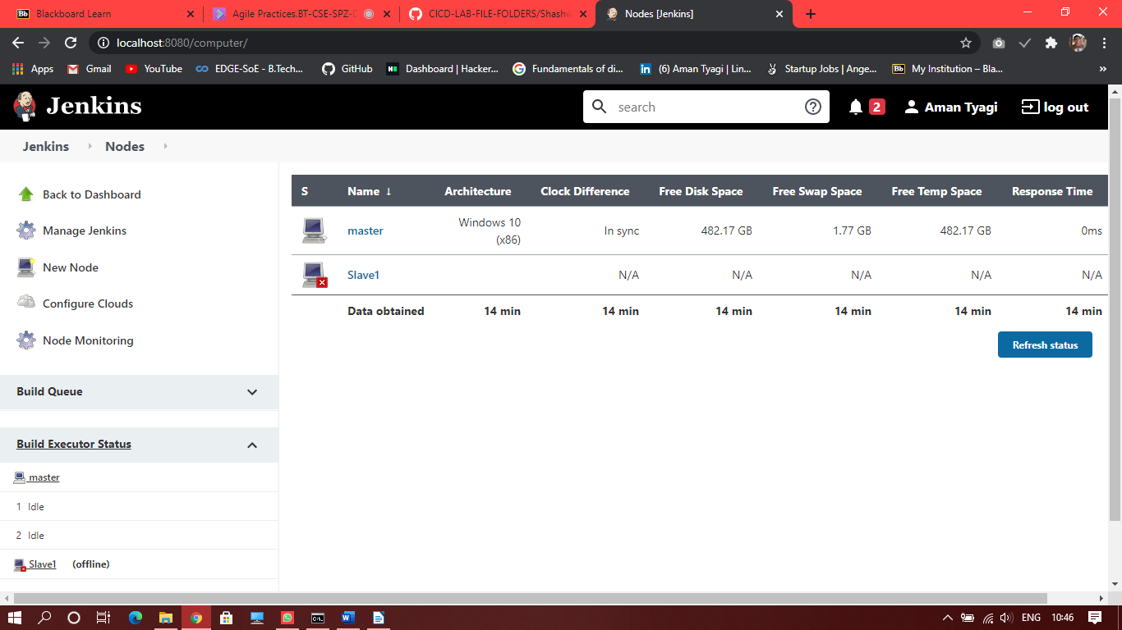

1. In the configurations provide the path of folder ( create a new folder for slave)

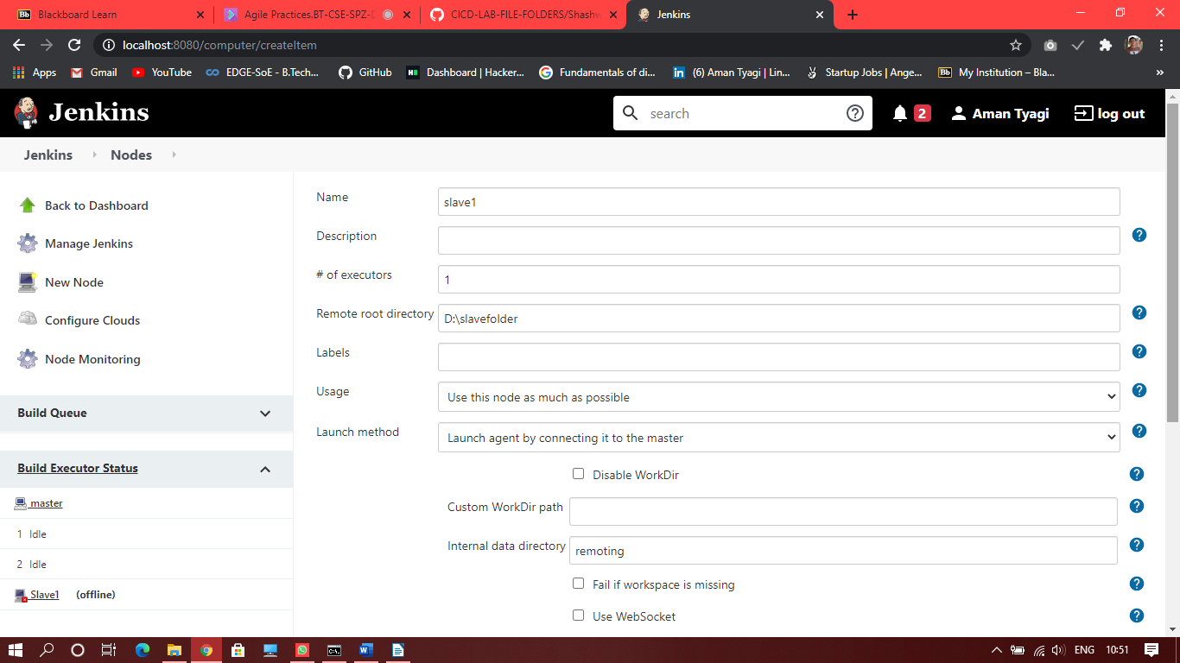

1. We will see a jar file created in the folder , then run cmd and traverse to this jar file and run the command provided in the configuration of slave1

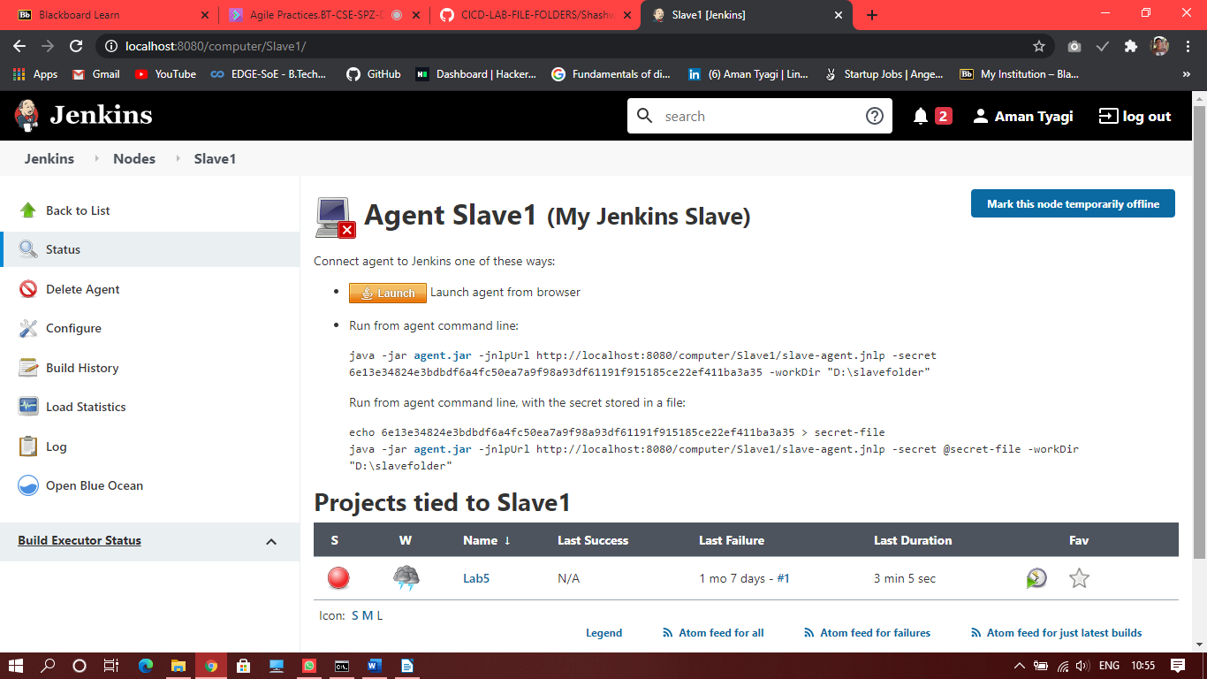

1. Running this command will make slave1 active

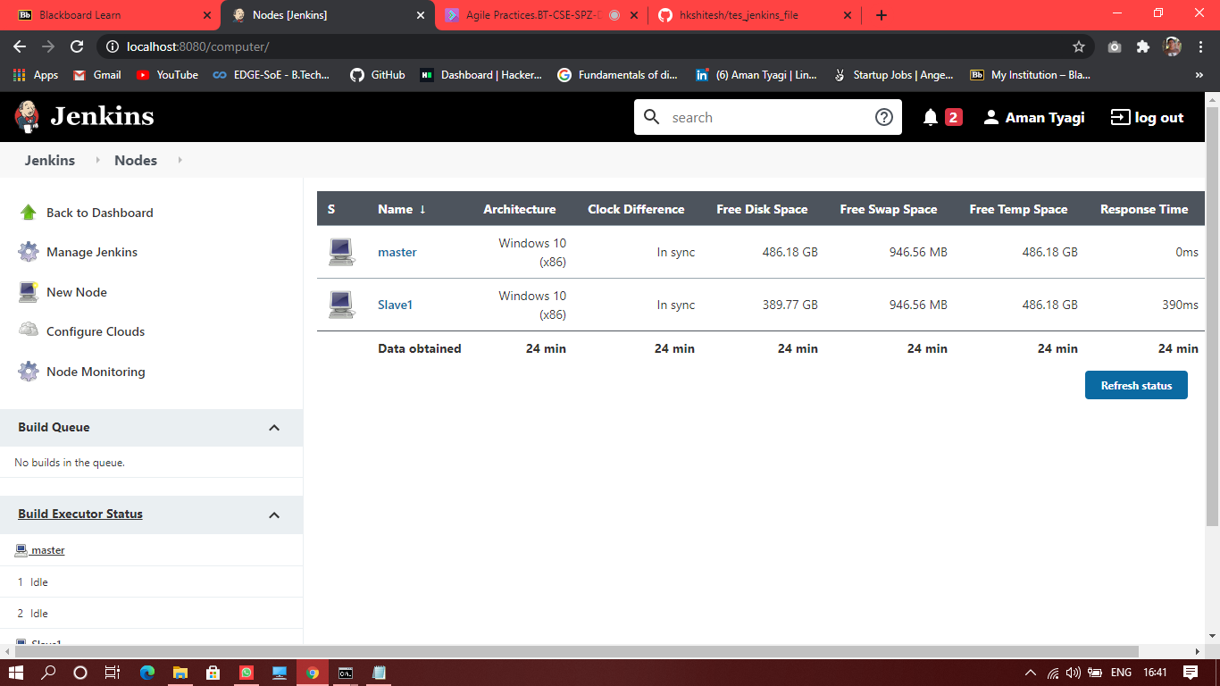

1. In the configuration of any maven project
2. Check the option “Restrict where this project can run”
3. Provide the name of the slave node “Slave 1” in the label expression and build the project

